Instructions for Registering on Stack Sports
Stack Sports is a registration site that we use so coaches can create rosters, so we can reach out to you with any CCS Club related news, and much more.
Visit http://ccs.alsoccerlive.org to get started.
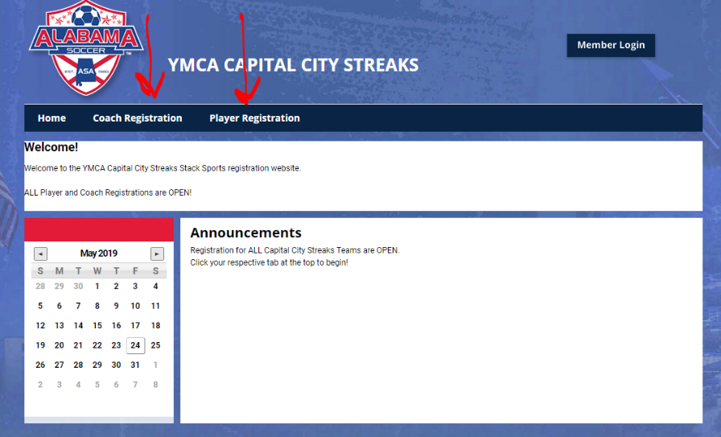
When you get to the home page, click on either the COACH or PLAYER tab at the top.

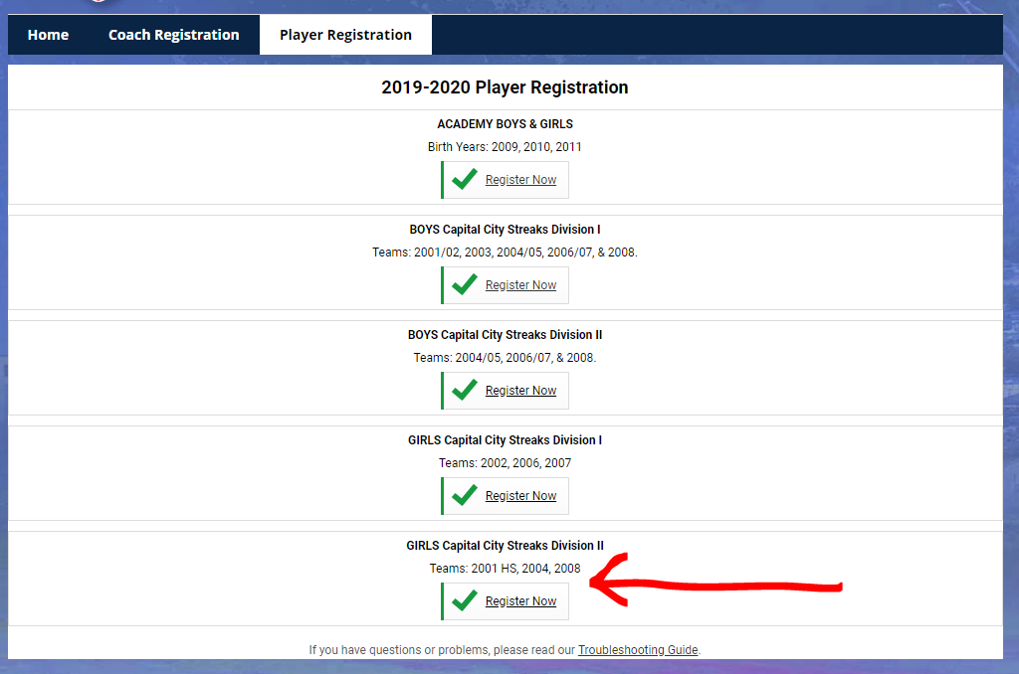
Once you are on your respective page, click one of the options determining the players/coaching Gender, Division, and Age. If they are 2009-2011, you will click the Academy option. For this demonstration, I’ll register for Girls Division II as a PLAYER.

** If you are unsure what team the player has made, email jason@ymcamontgomery.org to double check.
Once you’ve clicked the correct team, it will lead you to a login site. If you already have an account, continue by logging in.
If you have not created an account, do so now by clicking the New here? Create an Account link.
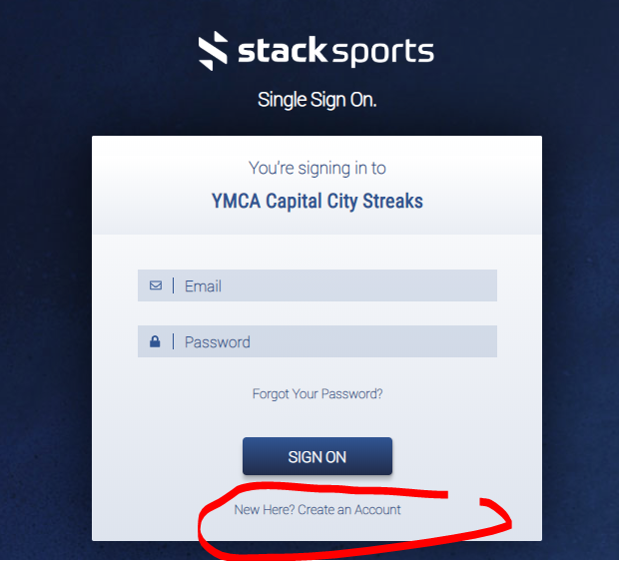
You will then go through a few different pages of entering parental info/your name. Keep filling everything out until you get to the page shown below, where it will provide you with a category to choose the AGE of your player from within the Gender/Division that you chose.
If you are registering for Academy, you will chose between Boys and Girls.
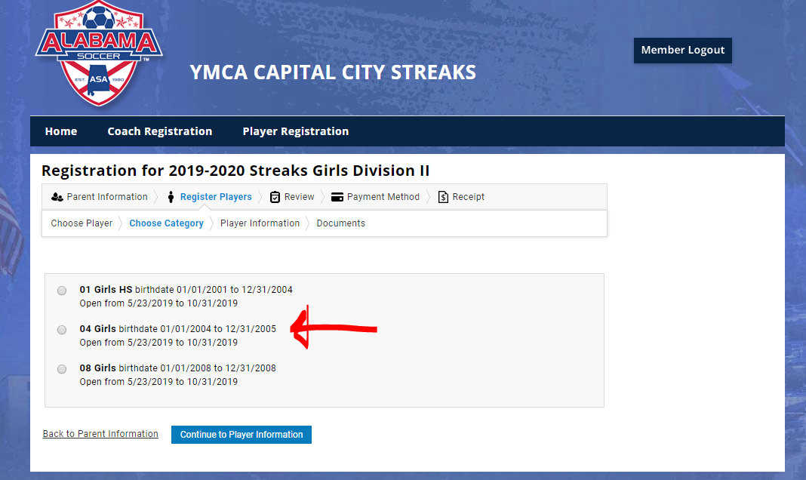
If your player is playing up, make sure you send an email to mharrison@ymcamontgomery.org with the birthdate of your player, and the age they will be playing for prior to signing up.
You will then be brought to the “player information” page, where you will fill out your player information accordingly.
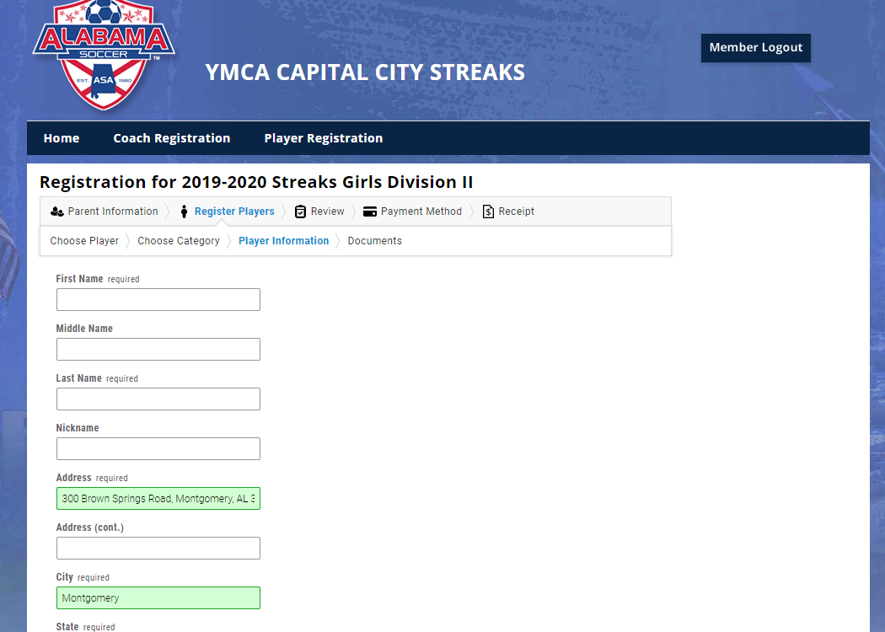
IF YOU ARE IN 08-01 FOR ANY GENDER AND ANY DIVISON, PLEASE PUT WHAT SCHOOL YOU ATTEND!!!
Once prompted, please upload a headshot and ID Documents so we do not have to track you down to do so.
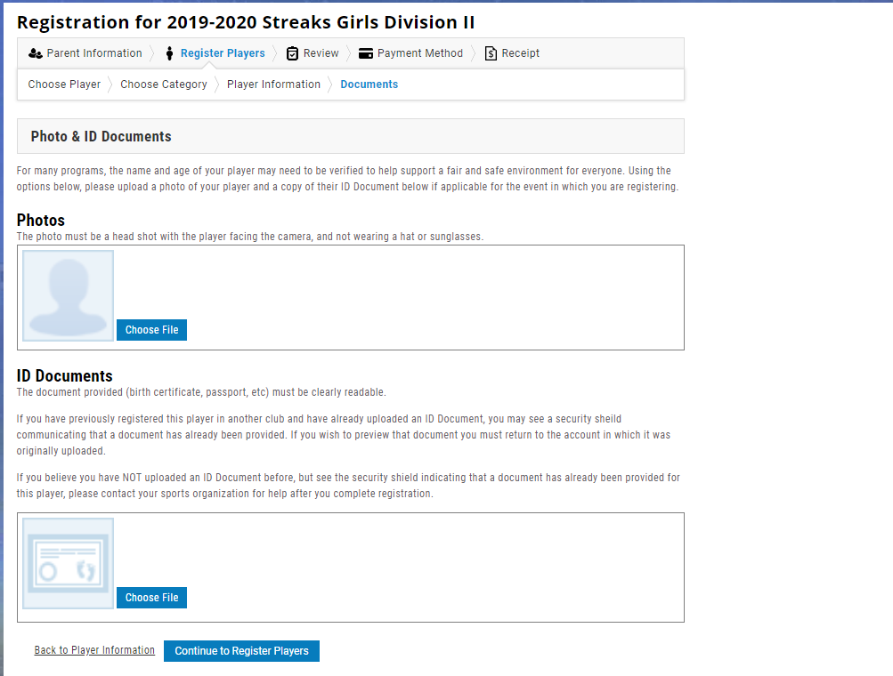
Once you’ve uploaded your player card headshot and your Documents, click continue to Register Player.
It will bring you to this page:
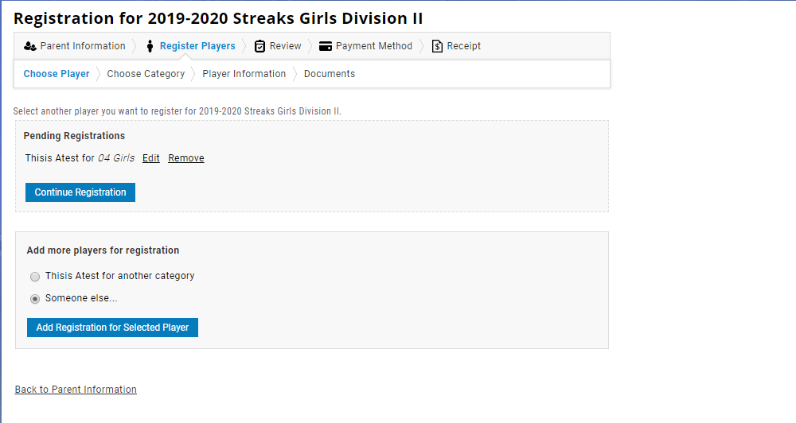

If you have multiple players registering, this is where you go to the “Add more players for registration” and select “someone else”, then add registration for selected players. You will go through the same process as before.
If you are done registering, go to the “pending registration” and click “continue registration”.
You will arrive at this page. There is NO fee to register on daxko, so click continue to payment method. We will not have you enter your payment info.
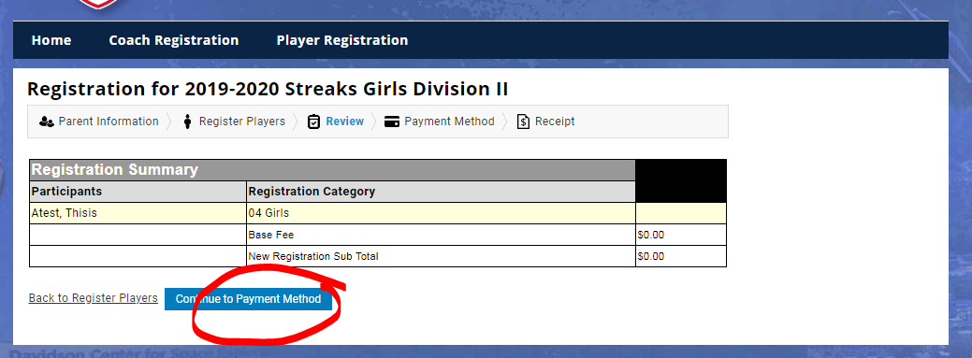

This is the page you will see after you hit “continue to payment method”. Click confirm registration. A page will pop up saying to check your email for confirmation.
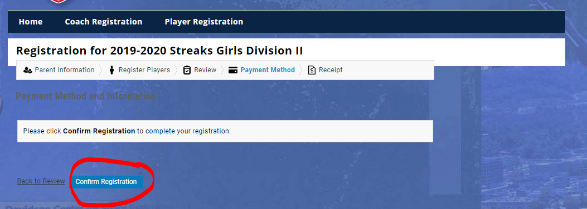
Once you see your confirmation email in your inbox, you’re all set.
Thanks for registering, and we’re looking forward to having you join us this fall!

